7. Architecture Decision & Diagrams
This section answers the M2 question "how should CivicConnect be structured, and why?". It starts from the approved ASRs in Section 6, compares realistic structural alternatives and records the selected structure with its diagrams. Technology choices are recorded in Section 9 (D05), the data model in Section 8, the API contract in Section 12 (D06) and environment direction in Section 13 (D07); this section references them rather than repeating them. Decisions made here are logged in Section 17 as D09 (architecture style) and D10 (request lifecycle state model).

7.1 Architectural drivers
Not every ASR changes the structure of the system. The table shows which Section 6 ASRs shape the architecture and what each one forces. ASR-003 and ASR-008 are affected by change requests raised in M2 (CR-004 and CR-005, Section 18) and are shown with their proposed direction.
Table 7-1. Section 6 ASRs and their structural consequence
ASR | Driver in short | Structural consequence in this architecture
ASR-001 | R0 budget, free tools | One deployable API process and one database, not a distributed system. Free, open-source components only (D05).
ASR-002 | Role-scoped data access | A single enforcement point: every request passes JWT verification and a role/ownership/category check in API middleware, and repositories filter by user_type and ownership. No page reads the database directly.
ASR-003 | No secret stored in plain text | Owned by the User module: passwords hashed with bcrypt (D05). Email confirmation tokens (D13, CR-004) are also stored only as hashes.
ASR-004 | 99.9% availability, failover | Stateless API so an instance can be restarted or replaced; all state in PostgreSQL. Standby database and failover are deferred to M3 (Section 13); see 7.6 and CR-006.
ASR-005 | Fast submit and processing | Slow side effects (email) run after the transaction commits and are not awaited by the HTTP response (D12). Oversight counts are computed by SQL, not in the browser.
ASR-006 | 210 concurrent users | No in-memory session state in the API (JWT), shared pg.Pool, so the API tier can scale horizontally behind one address.
ASR-007 | No lost or corrupted requests | One relational store with ACID transactions; a status change and its action row commit together or not at all (D12).
ASR-008 | Notifications, replaceable channels | A separate Notification module behind a NotificationChannel interface, so channels are added or swapped without touching request logic (D11).
ASR-009 | Oversight and staff audit | Every staff change writes an action row. A read-only Admin module serves summaries and audit views, separate from write use cases.
ASR-010 | Any device | One responsive React client (no native apps), shared by all roles.
7.2 Architecture alternatives considered
Four realistic structures were scored against the drivers above. Weights reflect the tightest limits identified in Section 5: team capacity and schedule (CON-RES-01, CON-SCH-01), then data integrity and access control.
Table 7-2. Weighted architecture decision matrix (1 = poor, 5 = strong; total = Σ weight × score ÷ 5)
Criterion (weight) | Layered modular monolith | Microservices | Serverless functions + hosted backend | Unstructured monolith (routes query the DB directly)
Team capability and schedule, CON-RES-01 / CON-SCH-01 (25) | 5 | 1 | 3 | 5
Transactional integrity and audit, ASR-007 / ASR-009 (20) | 5 | 2 | 3 | 4
One security boundary, ASR-002 (20) | 4 | 2 | 3 | 2
Running cost, ASR-001 (15) | 4 | 1 | 4 | 5
Testability (10) | 4 | 3 | 3 | 2
Replaceable parts, ASR-008 (10) | 4 | 4 | 2 | 1
Weighted total (out of 100) | 89 | 38 | 61 | 70

- Microservices (rejected). Splitting request, staff and oversight into separately deployed services would put a network boundary inside one business transaction (status change plus action row), which then needs distributed transactions or an outbox to satisfy ASR-007. It multiplies hosting, secrets and monitoring work against ASR-001 and a three-person team. A2 Task 1 already found a message broker disproportionate for in-process collaboration, and Section 12.1 reached the same view for the client–server boundary.
- Serverless functions with a hosted backend (rejected). Low cost, but authorisation ends up split between function code and provider-specific data rules, weakening ASR-002, and it raises the vendor lock-in risk recorded in Section 16 (Heroku, n.d.).
- Unstructured monolith (rejected). Lowest set-up effort, but route handlers that each query the database scatter validation and role checks across files. That is the "god service" failure described in A2 Task 1, and the audit guarantee in ASR-009 would depend on every developer remembering to write the action row.
- Layered modular monolith (selected, D09). One process and one database keep transactions simple, while module and layer boundaries give the separation ASR-002 and ASR-008 need. This follows the common advice to start with a well-modularised monolith and split only when evidence demands it (Fowler, 2015; Richards and Ford, 2020).

7.3 Selected architecture
CivicConnect is a layered modular monolith: one React client and one Node.js/Express API process backed by one PostgreSQL database, plus an external SMTP email provider. Inside the API, code is organised first by business module and then by layer. Figure 7-1 shows the system boundary and Figure 7-2 the internal structure.
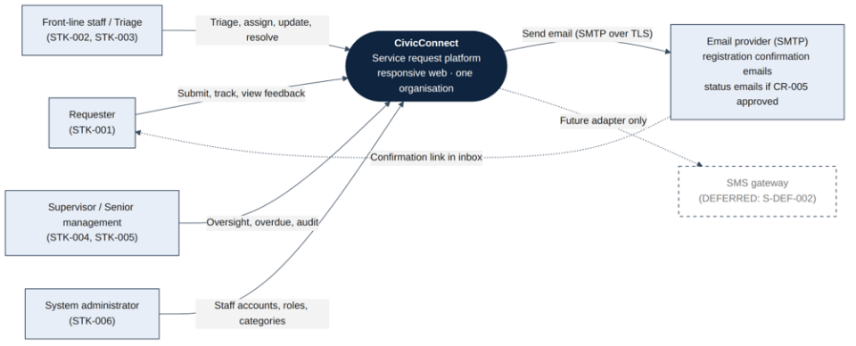
Figure 7-1. System context. The SMTP provider sends registration confirmation emails (D13) and status emails if CR-005 is approved. SMS is drawn dashed because it stays deferred (S-DEF-002).
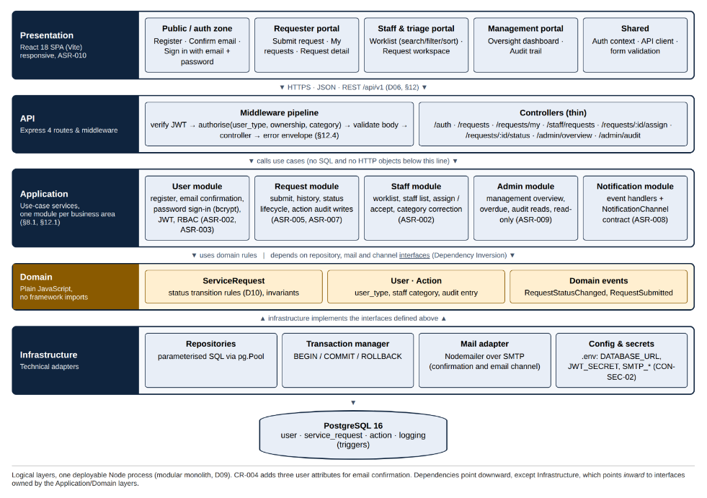
Figure 7-2. Logical architecture: five layers and five business modules. Arrows show the allowed dependency direction.
Dependency rules
These rules are checked in pull-request review now and by an ESLint import rule from M3:
- The React client calls the API only over HTTPS/JSON (/api/v1, Section 12). It holds no business rules beyond form checks for fast feedback.
- Controllers are thin: they translate HTTP to a use-case call and back and never contain SQL.
- Application services own the use cases and the transaction boundary. They depend on repository, mail and channel interfaces, never on pg or Nodemailer directly.
- Domain code imports nothing from Express, React or pg. Status transition rules live here so they can be unit tested without a database.
- Infrastructure implements the interfaces. Only this layer knows SQL, connection strings, SMTP settings and secrets.
- Modules call each other only through their application services, never through another module's repository.

Table 7-3. Module responsibilities and requirement allocation
Module | Responsibility | Requirements | Data it writes (Section 8)
User | Registration with email confirmation, email + password sign-in, JWT issue, role and category policy used by every other module | REQ-023, REQ-029, REQ-030, REQ-033 | user (incl. email_verified, verification_token_hash, verification_expires_at; CR-004)
Request | Submit a request once, requester history, status lifecycle and the action rows it produces | REQ-001 to REQ-006, REQ-013 to REQ-017, REQ-028, REQ-031, REQ-035 | service_request, action
Staff | Category-scoped worklist, full details, staff list, assign / accept, category correction | REQ-007 to REQ-012, REQ-024 | service_request (owner, category), action
Admin (management) | Read-only summaries, overdue detection, all-requests view, audit trail | REQ-018 to REQ-022 | none (reads only, ASR-009)
Notification | Reacts to domain events and delivers requester messages through NotificationChannel implementations | REQ-006, REQ-026 | none

Naming. Sections 8.1 and 12.1 name User, Request, Staff and Admin modules; this section keeps those names and adds the Notification module that ASR-008 asks for. The "Persistence module" in Section 8.1 (trigger-written logging table) is part of the Infrastructure layer here, because no application code writes to it. The Admin module serves the management role; system-administrator tasks (staff accounts and categories) are handled by the User module.
7.4 Physical view and environments
The five layers in Figure 7-2 are logical: they are folders and import rules, not servers, so adding a layer costs no network hop. Physically there are four runtime parts: the browser, one Node.js process, one PostgreSQL server and the email provider. Section 13 sets out the environment strategy; Figure 7-3 shows how this architecture maps onto it.
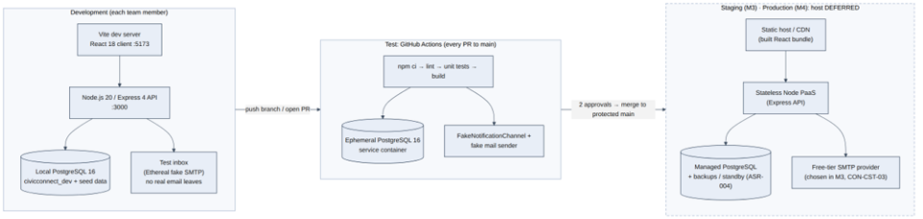

Figure 7-3. Environment mapping. Development and CI are defined now; the staging/production host and SMTP provider are chosen in M3 (dashed).
- No real email outside production. Development uses a fake SMTP inbox (Ethereal) and CI uses the FakeNotificationChannel and a fake mail sender, so tests never email real people and need no SMTP secret.
- Stateless API. Authentication is a signed JWT and all domain state is in PostgreSQL, so an API instance can restart or be duplicated (ASR-004, ASR-006). Email confirmation tokens are also stored in PostgreSQL, never in memory.
7.5 Request lifecycle state model (D10)
Scope item S-IN-007 requires a state model covering rejection, cancellation and reopening. The baseline currently uses several status vocabularies: REQ-004 (pending, accepted, rejected, updated, completed), REQ-013 (pending, in progress, completed), REQ-022 (open, closed, resolved, overdue), Section 8.1 (Pending → Accepted/Assigned → In Progress → Completed/Resolved, or Rejected/Closed) and Section 12.2 (Pending, Accepted, In Progress, Completed, Rejected). REQ-017 also sets a closed request to "Rejected". Workflow, audit, requester feedback and oversight must all read the same values, so the state model is an architectural decision.
D10 keeps the names the team already uses in Sections 8.1 and 12.2 and adds only what S-IN-007 requires.
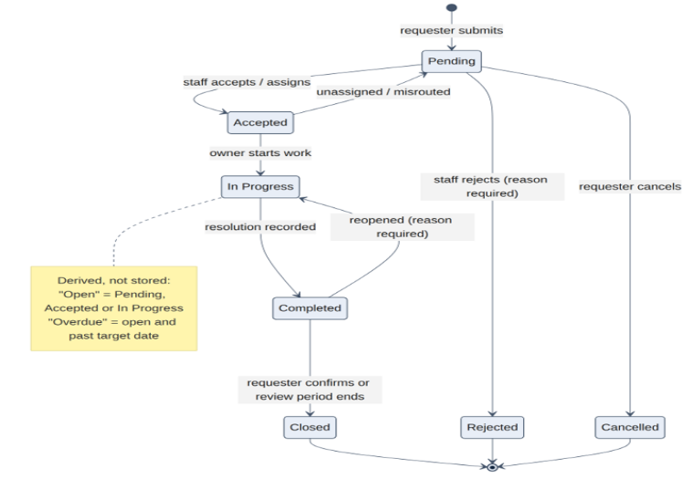

Figure 7-4. Request lifecycle. Seven stored states. "Open" and "Overdue" are derived when read, never stored.
Table 7-4. Mapping of existing status wording to the D10 state model
Existing wording (source) | D10 | Change needed
pending (REQ-004, REQ-013, §8.1, §12.2); open (REQ-022) | Pending. "Open" is derived: Pending, Accepted or In Progress | None
accepted (REQ-004); Accepted/Assigned (§8.1) | Accepted (a staff owner exists) | None
in progress (REQ-013, §8.1, §12.2) | In Progress | None
updated (REQ-004) | Not a state. An update is an action row shown in the timeline | REQ-004 criterion reworded (CR-003)
completed (REQ-004, REQ-013, REQ-016); resolved (REQ-022) | Completed. Oversight labels it "Resolved" | None
closed (REQ-017, REQ-022) | Closed. REQ-017's "set to Rejected" is replaced: rejection is its own transition from Pending | REQ-017 criterion corrected (CR-003)
rejected (REQ-004, §12.2) | Rejected (reason required) | None
overdue (REQ-022) | Derived: open and past the target date, which is itself calculated as created_at plus the approved number of days for the category (S-IN-010), so no extra database attribute is needed | None
(new) cancel, reopen (S-IN-007) | Cancelled (requester, from Pending only); Completed → In Progress on reopen | Adds behaviour required by S-IN-007 (CR-003)

Section 8.3 requires that "Status must follow a valid transition sequence". D10 supplies that sequence: the allowed transitions live in the ServiceRequest domain object, the API returns 409 Conflict for any other move (Section 12.4), and a CHECK constraint limits the stored value to the seven names.
7.6 Key runtime interaction: changing a request's status
Figure 7-5 shows the most architecturally important flow because it exercises ASR-002 (authorisation), ASR-007 and ASR-009 (one transaction with its action row) and ASR-005 and ASR-008 (notification after commit, not blocking the response). The design reasoning is recorded in Section 11 (D12).
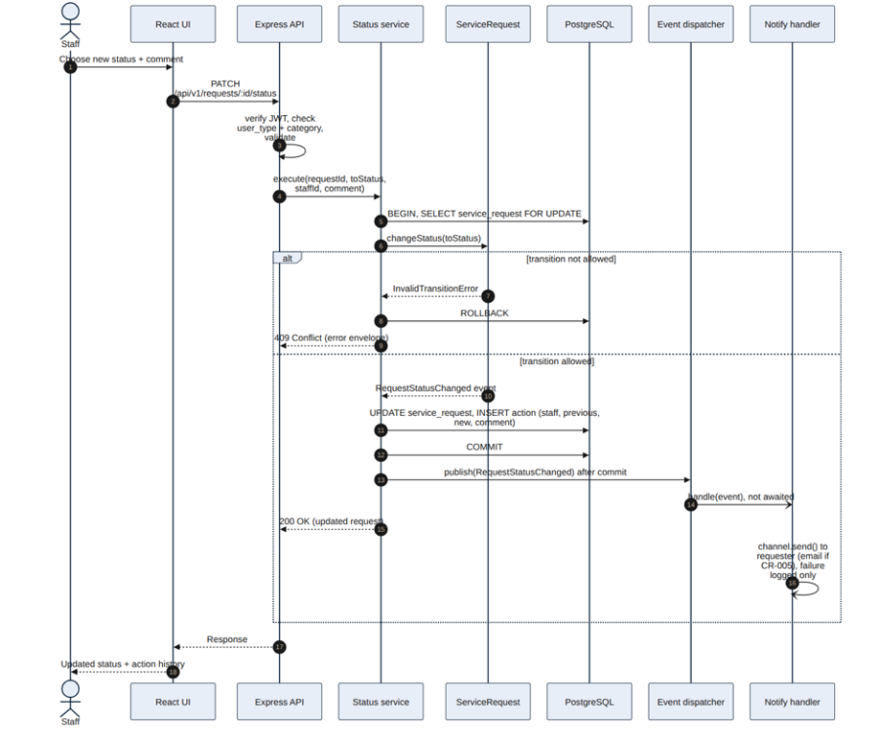

Figure 7-5. Status change. The state change and the action row commit together; the notification handler runs after commit and is not awaited.
7.7 Availability position (ASR-004)
ASR-004 asks for 99.9% availability (about 8.8 hours of downtime a year) and database failover. The architecture keeps that path open: the API is stateless, all state sits in one PostgreSQL database, and pg.Pool reconnects after a database switch. However, three baselined statements do not yet agree. Section 8.5.3 assumes automatic failover to a replica, Section 8.5.4 plans weekly manual backups (so up to seven days of data could be lost), and Section 13 defers failover to M3. None of these can be verified on free-tier hosting in M2. CR-006 proposes restating ASR-004, REQ-034 and REQ-036 as measurable recovery targets (RPO and RTO) once the M3 host is chosen, with the standby database as the preferred way to meet them. Until the CR is decided, the ASR stands and is tracked as R05.
Decisions recorded from this section (Section 17)
D09 Layered modular monolith with five modules. D10 One request lifecycle state model. Full records are in the Engineering Decision Log.

